File 41_marea_transit_service.csv
May 29, 2026
Definition of the Input File

This file (see https://visioneval.github.io/docs/model-inputs.html) contains 8 attributes all giving revenue miles for different forms of transit: demand-responsive (DR), vanpool (VP), regular bus (MB), rapid bus (RB), monorail or automated guideway (MG), streetcar and trolleybus (SR), light or heavy rail (HR), and commuter rail (CR). For example, suppose one is looking at the Charlottesville-Albemarle area. The data suggest that an Marea comprised of both of these counties will, in 2024 and in 2045, have 1.43 million revenue miles for paratransit (e.g., demand response) and 1.043 million revenue miles for regular bus service.
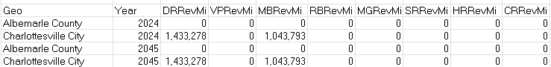
Other locations in Virginia, such as Fredericksburg, will show a value for commuter rail (CR) and those in Northern Virginia, such as Arlington and Fairfax County, will show a value for heavy rail (HR).
Possible Scenario
Changing transit service, as shown in the document Task 7.2 Simplified Scenario Development guide, available at A Playbook for Simplified Approaches for Creating Scenarios in VisionEval, is a substantial policy for VisionEval. That document asks “How would travel behavior change if the availability of transit were double what it is today? This topic explores the question of increasing the overall supply of transit options to a region. Transit considers both the extent to which the service is available (coverage) and the frequency of that service.” This file (marea_transit_service.csv) should be modified in conjunction with the file bzone_transit_service.csv which gives service frequency.
Method Used for Virginia
The National Transit Database was used as a starting point for these data. There are five items that users may wish to consider when applying these data in their own region. None of these are believed to be a fatal flaw at this point but may merit greater study if a user is developing a scenario highly sensitive to changes in these inputs.
- The NTD is comprehensive but not complete, as it does not include transit systems that do not receive federal funds. In the past, this would have been a problem for the City of Charlottesville, which has three systems: Charlottesville Area Transit (CAT), Jaunt (a paratransit system), and the University of Virginia Transit system (UTS). In the past, only the first two might have been shown in the NTD because the UTS did not receive federal funds. In the past, this problem did not occur with another large university (Virginia Tech) because in that case, the university transit system and the city’s transit system are a single agency (Blacksburg Transit) which does receive federal funds and is in the NTD. However, it now appears that UTS operations are indeed incorporated into those with CAT, such that the NTD reporting for CAT will be complete. However, if there are other agencies in Virginia that did not receive federal funds, this could be a problem. (Note that DRPT also maintains a dashboard which appears similar to that of the NTD; see https://drpt.virginia.gov/data/performance-measures/transit-performance-data-dashboard/)

- There is not always a one-to-one mapping between the locations in the NTD and the locations of service. For example, consider the Virginia Railway Express (VRE) which operates between Union Station (in Washington, D.C.) and Prince William County (one leg) and Spotsylvania (another leg). For this commuter rail system, the NTD places all 2,413,451 revenue miles from 2023 (estimated to be 2,593,603 revenue miles in 2024) in Alexandria. However, as shown by the system map for the VRE (https://www.vre.org/service/system-map/), these revenue miles do not all occur in Alexandria; rather, they occur in Alexandria, Arlington, Fairfax County, Prince William, Stafford, Manassas, Manassas Park, Spotsylvania, and Stafford. To estimate the revenue-miles for each jurisdiction, printed page 76 of the VRE financial report (https://www.vre.org/assets/1/6/Annual_Comprehensive_Financial_Report_2024.pdf) gives contributions from these agencies, and thus it was assumed that revenue-miles would be proportional to these contributions. For example, because Fairfax County contributed $5,005,547 out of a total statewide contribution of $16,000,000, Fairfax County was assigned ($5,005,547/$16,000,000)* 2,593,603 = 811,400 revenue miles.

- Similarly, the Washington Metropolitan Area Transit Authority (WMATA) does not have all of its miles occur in Washington but rather its miles are spread across (besides DC), suburban Maryland, Arlington, Alexandria, Fairfax County, and Loudoun. Table 6 (shown on printed page 9) of https://www.wmata.com/content/dam/wmata-com/migrated-assets/about/records/upload/fy2024-dedicated-funding-report.pdf shows contributions by agency, and these were used to allocate WMATA’s heavy rail, metrobus, and paratransit operations. This is a simplification—e.g., the above does not include Prince William County, even though WMATA provides some service (e.g., to Woodbridge) but based on another report that defines the WMATA “Transit Zone” (https://rga.lis.virginia.gov/Published/2024/RD965/PDF) this approach seems reasonable.

- As with all input files, there is some judgement as to what should be the default case for the forecast year of 2045. For example, one could argue that there should be growth in transit service to the extent that there is growth in the drivers of travel demand, such as population or employment. However, because transit (as is the case with other modes) is subsidized, such an assumption also implies one should expect a continued increase in funds for transit. The research team has used a method to increase 2045 revenue miles as shown in step 3.2.6 and as shown in the corresponding Excel file should users wish to incorporate such values as a default increase. However, it a case can also be made to presume no increase in revenue miles as a base case between 2024 and 2045 (or to let regions use their own increase). Thus the corresponding CSV file has set 2045 revenue miles equal to 2024 revenue miles.

- Vanpool revenue miles and bus rapid transit revenue miles are currently zero. It is probably the case that what is characterized as regular bus service in a few locations, such as Fairfax County where buses may operate free of charge in the 65 mph express lanes, could be considered bus rapid transit. Similarly there are some vanpool services in the state. If a user develops a scenario that increases the demand for these services, then it would be appropriate to experiment with the revenue miles inputs.
On balance, the second and third consideration can be minimized at the regional level, because one only needs the marea for revenue miles—that is, even though some of Charlottesville Area Transit (CAT) revenue miles are in Albemarle, this is not a fatal flaw as an analysis for that region will use the entire Marea.
Computational steps follow.
- Source: National Transit Database (NTD) 2023 TS2.1 Service Data and Operating Expenses Time Series by Mode
  - URL: https://www.transit.dot.gov/ntd/ntd-data
  - Location: NTD Data–NTD Data Reports
  - Search Keyword: VRM (Vehicle Revenue Miles)
  - Related Sheet: VRM

- Year that the Data Reflect: 2024 (The 2024 value was projected using data from 2021 to 2023.)
- 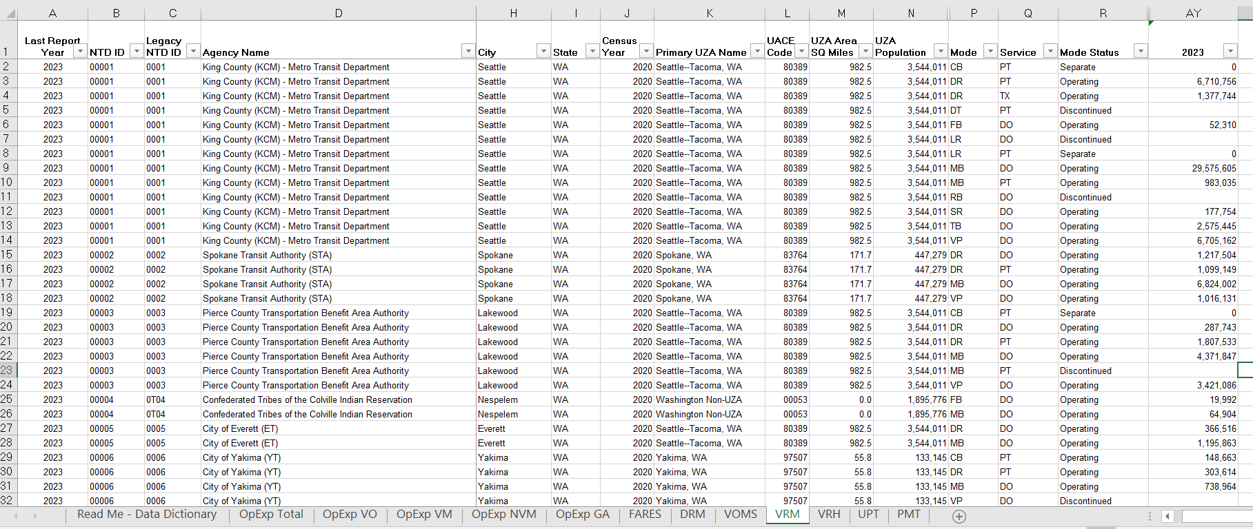

- How the Data Were Processed
  - Option 1: UZA Name-Based Aggregation
    - Excel Filtering: Filtered by State = VA and Mode Status = Operating 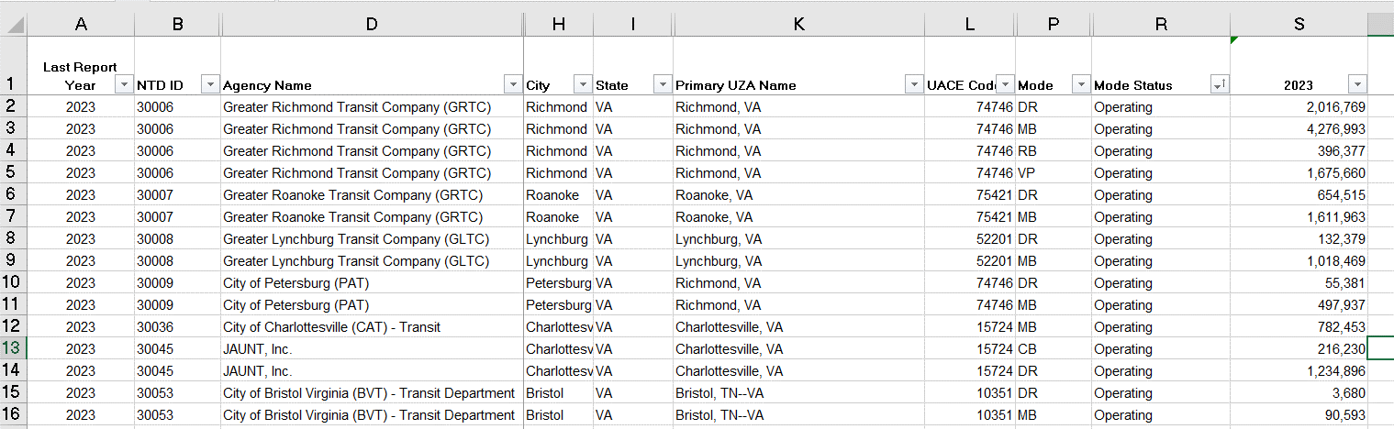
    - Pivot Table Construction: Primary UZA Name (rows), Mode (Columns), 2023 VRM (summed as values) 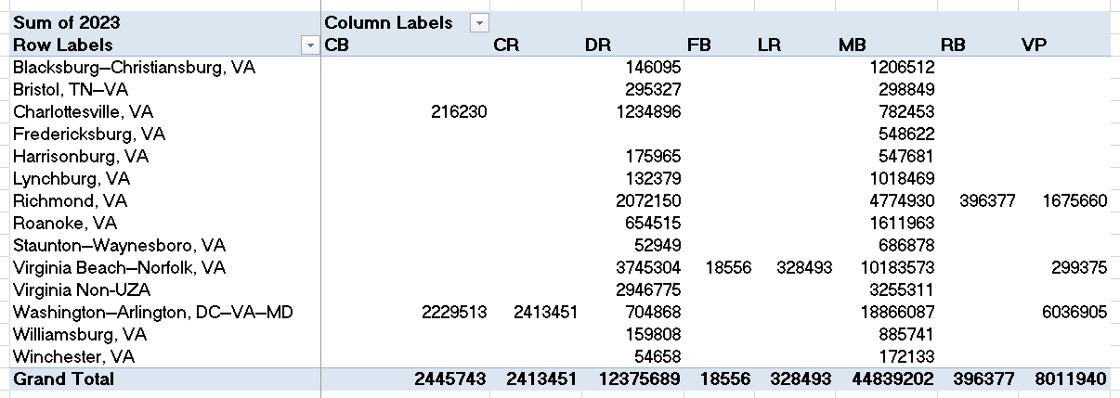
    - Mode classification and exclusion
Mode | NTD Glossary | Input | Description
CB | Commuter Bus | MBRevMi | Grouped with MB due to no HOT access
CR | Commuter Rail | CRRevMi
DR | Demand Response | DRRevMi
FB | Ferryboat |  | Excluded
LR | Light Rail | SRRevMi | Classified under SRRevMi
MB | Bus | MBRevMi
RB | Bus Rapid Transit | RBRevMi
VP | Vanpool | VPRevMi

    - UZA Name Normalization: Commas within text fields were removed to prevent CSV parsing errors.
Original UZA Name | Modified UZA Name
Blacksburg--Christiansburg, VA | Blacksburg--Christiansburg
Bristol, TN--VA | Bristol, TN--VA
Charlottesville, VA | Charlottesville
Fredericksburg, VA | Fredericksburg
Harrisonburg, VA | Harrisonburg

    - Result Summary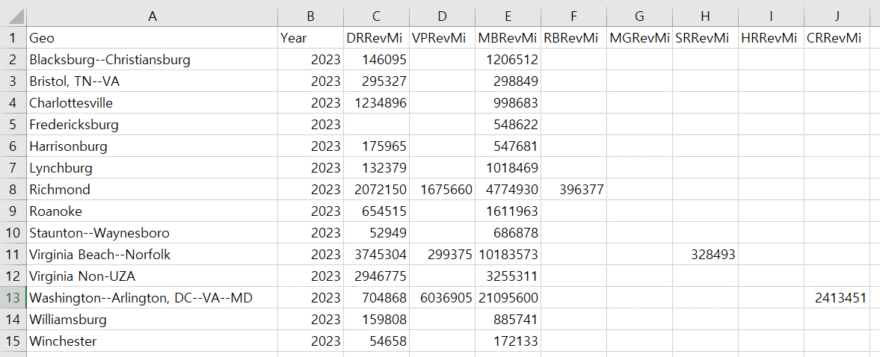

    - Limitation: This method groups smaller cities without UZA designation (e.g., Danville and 13 others) to be grouped under Virginia Non-UZA.

  - Option 2: City-Based Aggregation
    - Excel Filtering: Filtered by State = VA and Mode Status = Operating 
    - Pivot Table Construction: City (rows), Mode (Columns), 2023 VRM (summed as values) 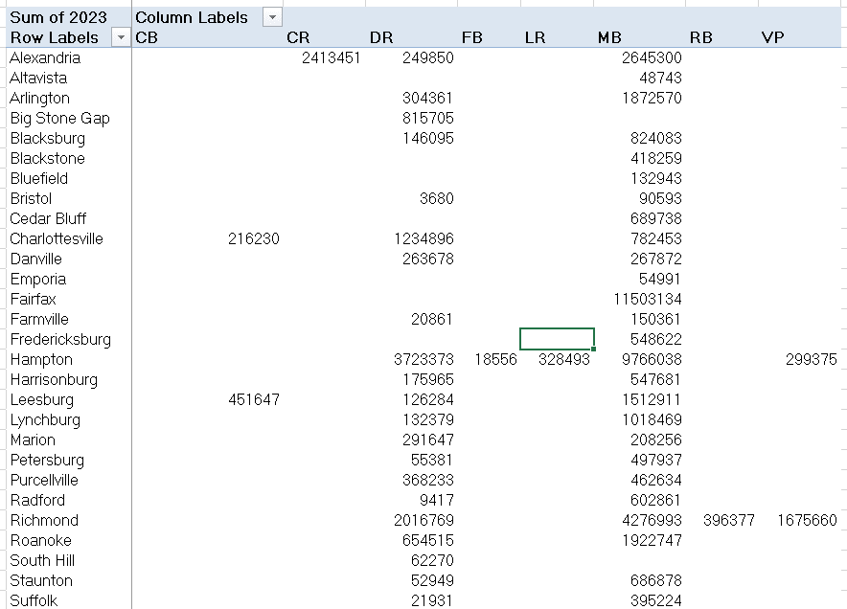
    - Mode classification and exclusion
Mode | NTD Glossary | Input | Description
CB | Commuter Bus | MBRevMi | Grouped with MB due to no HOT access
CR | Commuter Rail | CRRevMi
DR | Demand Response | DRRevMi
FB | Ferryboat |  | Excluded
LR | Light Rail | SRRevMi | Classified under SRRevMi
MB | Bus | MBRevMi
RB | Bus Rapid Transit | RBRevMi
VP | Vanpool | VPRevMi

    - Intermediate Result 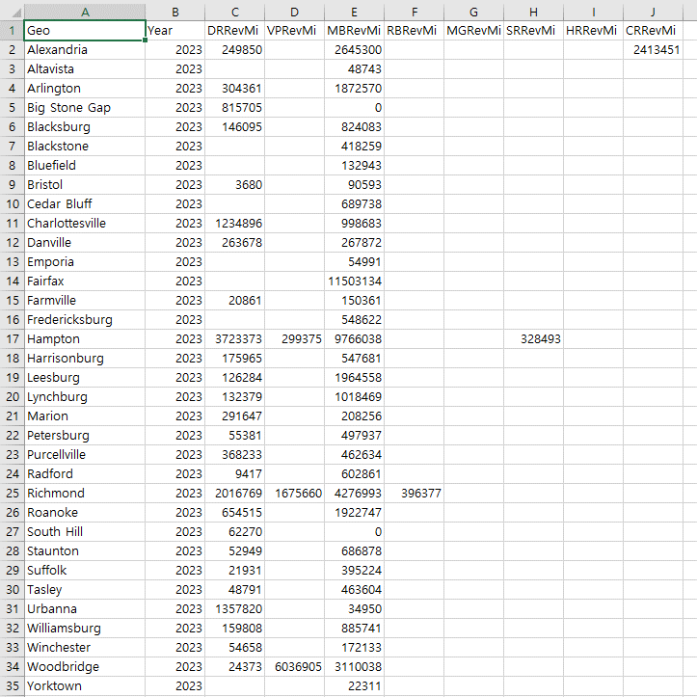
    - Mapping for geographic consistency
Number | Geography | marea_transit_service | Number | Geography | marea_transit_service
1 | Accomack County | Tasley | 71 | Loudoun County | Leesburg + Purcellville
2 | Albemarle County |  | 72 | Louisa County
3 | Alexandria City | Alexandria | 73 | Lunenburg County
4 | Alleghany County |  | 74 | Lynchburg City | Lynchburg
5 | Amelia County |  | 75 | Madison County
6 | Amherst County |  | 76 | Manassas City
7 | Appomattox County |  | 77 | Manassas Park City
8 | Arlington County | Arlington | 78 | Martinsville City
9 | Augusta County |  | 79 | Mathews County
10 | Bath County |  | 80 | Mecklenburg County | South Hill
11 | Bedford County |  | 81 | Middlesex County | Urbanna
12 | Bland County |  | 82 | Montgomery County | Blacksburg
13 | Botetourt County |  | 83 | Nelson County
14 | Bristol City | Bristol | 84 | New Kent County
15 | Brunswick County |  | 85 | Newport News City
16 | Buchanan County |  | 86 | Norfolk City
17 | Buckingham County |  | 87 | Northampton County
18 | Buena Vista City |  | 88 | Northumberland County
19 | Campbell County | Altavista | 89 | Norton City
20 | Caroline County |  | 90 | Nottoway County | Blackstone
21 | Carroll County |  | 91 | Orange County
22 | Charles City County |  | 92 | Page County
23 | Charlotte County |  | 93 | Patrick County
24 | Charlottesville City | Charlottesville | 94 | Petersburg City | Petersburg
25 | Chesapeake City |  | 95 | Pittsylvania County
26 | Chesterfield County |  | 96 | Poquoson City
27 | Clarke County |  | 97 | Portsmouth City
28 | Colonial Heights City |  | 98 | Powhatan County
29 | Covington City |  | 99 | Prince Edward County | Farmville
30 | Craig County |  | 100 | Prince George County
31 | Culpeper County |  | 101 | Prince William County | Woodbridge
32 | Cumberland County |  | 102 | Pulaski County
33 | Danville City | Danville | 103 | Radford City | Radford
34 | Dickenson County |  | 104 | Rappahannock County
35 | Dinwiddie County |  | 105 | Richmond City | Richmond
36 | Emporia City | Emporia | 106 | Richmond County
37 | Essex County |  | 107 | Roanoke City | Roanoke
38 | Fairfax City | Fairfax | 108 | Roanoke County
39 | Fairfax County |  | 109 | Rockbridge County
40 | Falls Church City |  | 110 | Rockingham County
41 | Fauquier County |  | 111 | Russell County
42 | Floyd County |  | 112 | Salem City
43 | Fluvanna County |  | 113 | Scott County
44 | Franklin City |  | 114 | Shenandoah County
45 | Franklin County |  | 115 | Smyth County | Marion
46 | Frederick County |  | 116 | Southampton County
47 | Fredericksburg City | Fredericksburg | 117 | Spotsylvania County
48 | Galax City |  | 118 | Stafford County
49 | Giles County |  | 119 | Staunton City | Staunton
50 | Gloucester County |  | 120 | Suffolk City | Suffolk
51 | Goochland County |  | 121 | Surry County
52 | Grayson County |  | 122 | Sussex County
53 | Greene County |  | 123 | Tazewell County | Bluefield+Cedar Bluff
54 | Greensville County |  | 124 | Virginia Beach City
55 | Halifax County |  | 125 | Warren County
56 | Hampton City | Hampton | 126 | Washington County
57 | Hanover County |  | 127 | Waynesboro City
58 | Harrisonburg City | Harrisonburg | 128 | Westmoreland County
59 | Henrico County |  | 129 | Williamsburg City | Williamsburg
60 | Henry County |  | 130 | Winchester City | Winchester
61 | Highland County |  | 131 | Wise County | Big Stone Gap
62 | Hopewell City |  | 132 | Wythe County
63 | Isle of Wight County |  | 133 | York County | Yorktown
64 | James City County
65 | King and Queen County
66 | King George County
67 | King William County
68 | Lancaster County
69 | Lee County
70 | Lexington City

    - Base Year and Target Year Data Projection: The 2024 value was projected by calculating the compound annual growth rate (CAGR) based on three years of historical data (2021–2023).(Updated July 9, 2025) 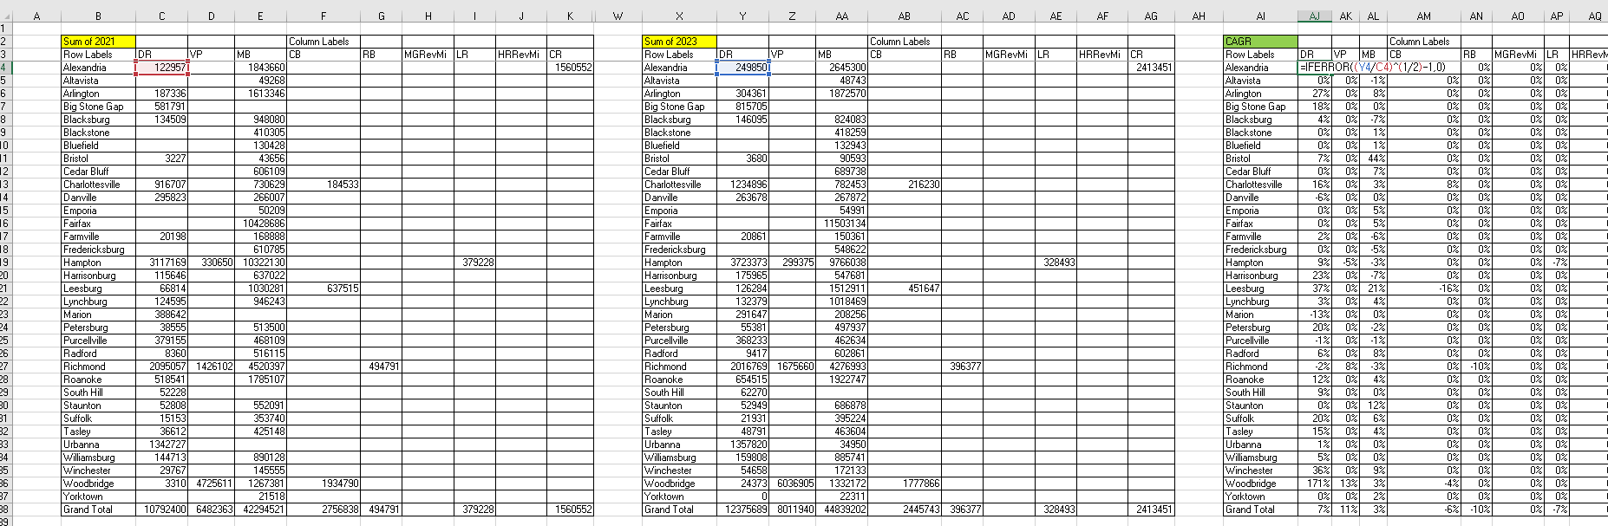
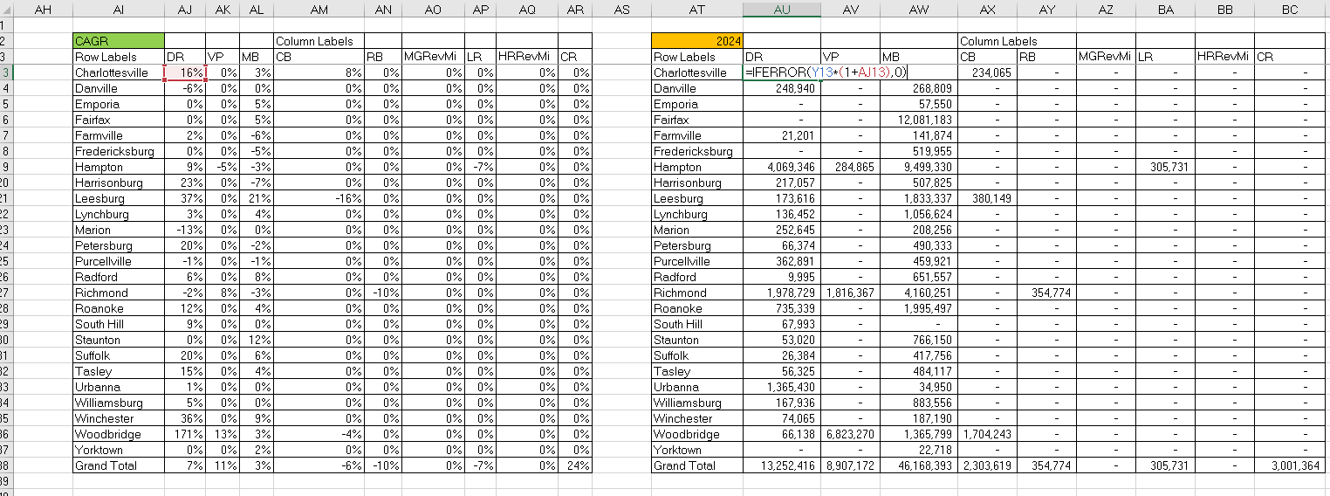
In some locations, such as Woodbridge—the calculated CAGR was relatively high, which could result in unrealistically inflated long-term projections.
To address this, the 2045 values were adjusted by applying the overall (Grand Total) growth rate proportionally across all counties and cities. Due to the high compound annual growth rate (CAGR) observed for Commuter Rail (CR) in Alexandria, the year-over-year growth rate from 2022 to 2023 (7%) was used instead. These values are shown in the Excel file, but the CSV file sets the 2045 values equal to the 2024 values.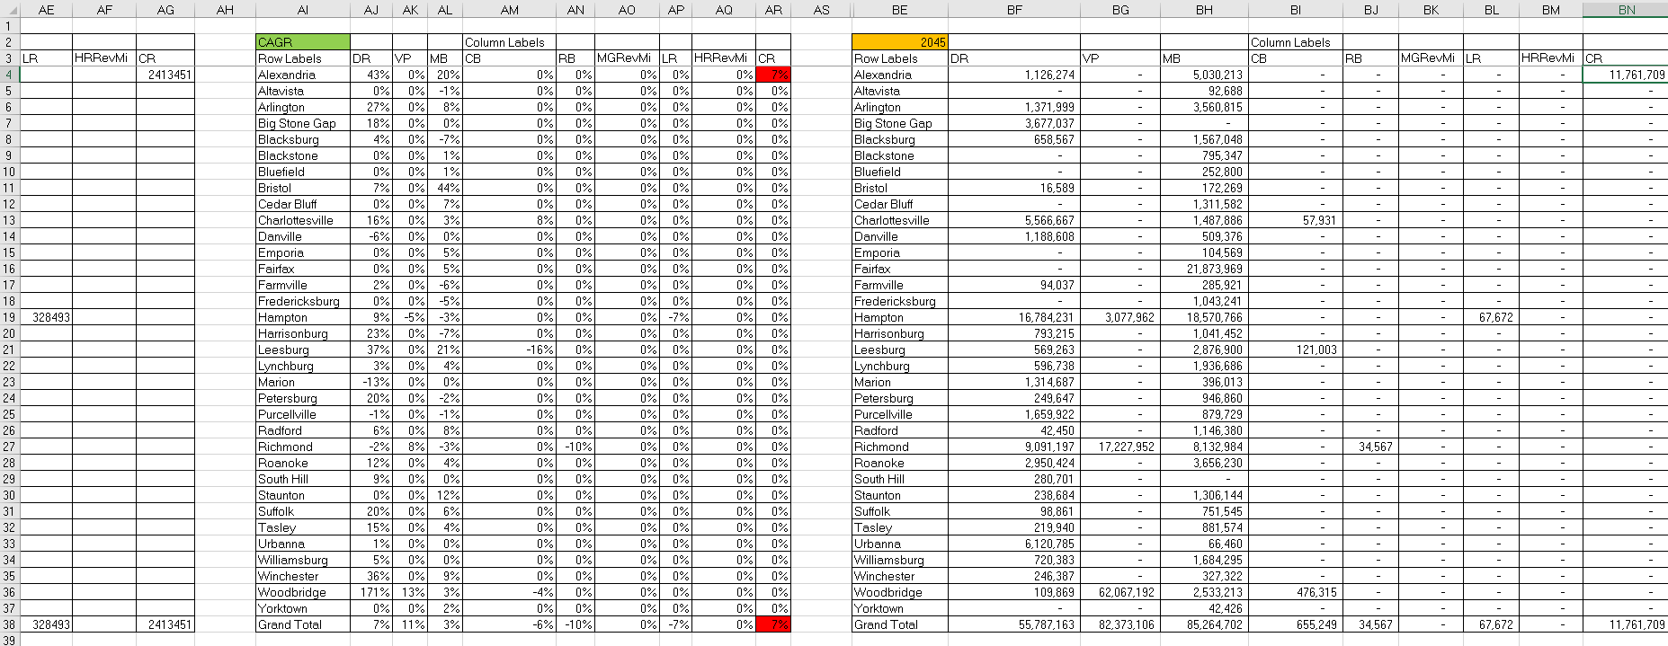
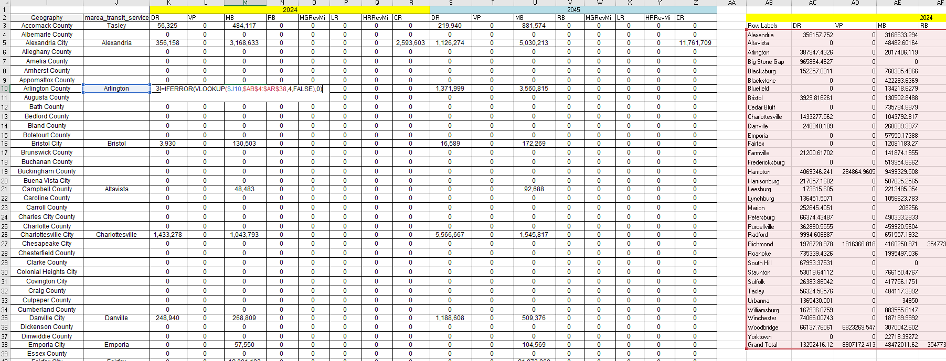

    - Result 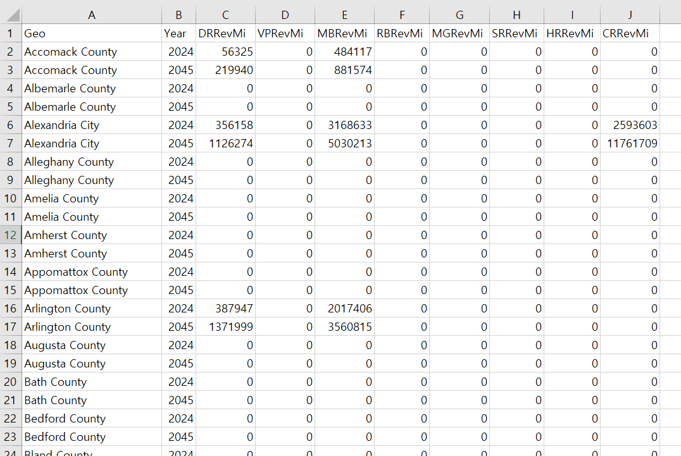
4. Make adjustments. The above results are placed in the sheet “Almost Final.” Then, adjustments for VRE and WMATA are shown in the sheet “Adjustments” and the reported CSV file is shown therein.

Appendix. VRM Data Source Comparison
Purpose: Multiple datasets related to Vehicle Revenue Miles (VRM) are available on the National Transit Database (NTD) website. This appendix evaluates which dataset is most suitable for use in the VisionEval model.
Comparison: The table below presents a side-by-side comparison of three different VRM datasets from the NTD.
Feature | 2023 TS2.1 Service Data and Operating Expenses Time Series by Mode | March 2025 Complete Monthly Ridership (with adjustments and estimates)_250430 | 2023 Federal Funding Allocation
Data Year | 2023 is the most recent complete dataset | Most recent data available as of March 2025 (monthly-based) | No data available for 2024–2025
Data Accuracy | Appears reliable (includes Charlottesville CAT data) | Contains partial gaps (e.g., Charlottesville CAT) | Some figures appear unrealistically low
Time Coverage | Annual data only | Monthly time series data available | Based on FY (Fiscal Year); requires conversion to calendar year

Example: VRM figures for Charlottesville in 2023.
NTD ID | Agency Name | Primary UZA Name | Mode | 2023 TS2.1 | Monthly Ridership | Federal Funding Allocation
30045 | JAUNT, Inc. | Charlottesville, VA | CB | 216,230 | 214,419 | 30,809
 |  |  | DR | 1,234,896 | 1,191,983 | 538,415
30036 | City of Charlottesville (CAT) - Transit |  | MB | 782,453 | NA | 505,465
 | Greater Richmond Transit Company |  | VP | NA | NA | 4,859

Result: The 2023 TS2.1 Service Data and Operating Expenses Time Series by Mode appears to be the most appropriate dataset for use in VisionEval.

